Reversible Rover

Subject:Physics, Mechanical Engineering, Electronics  Related Subjects:Mechanical advantage, motion, electricity, friction, torque | Grade Level(s):2,3,4,6,8  Length of Lesson: | Type: Inquiry / Design / Project  Keywords:Series circuit, gearing, axle, chassis, alignment, horsepower (torque x rpm), suspension

Lesson Overview

Anyone who has been on a bike or in a stick shift car has felt the effects of gearing and mechanical advantage causing motion. Some energy source (your legs or a motor) causes an object to turn. That object turns another object causing the vehicle to move forward.

Lesson Focus
Each student will create a chassis, wheels, gearing system and an electrical circuit in a car that actually works! Students will then test cars for speed and endurance.

Lesson Objective(s) | - Students build suspension (wheels and axles) from cans, foam core and wood dowels.  - Students build chassis from wood base shoe and foam core.  - Students create series circuit with motor, batter holder and switch  - Students assemble USC rover.  - Students demonstrate mechanical advantage by connecting gears (motor stem to can wheel) via rubber band.  - Students determine which design leads to better performance in  - Speed  - Direction  - Incline  - “Off road” conditions  - Students will also demonstrate trade-off of beauty versus function

Lesson Timing

5 minutes | Introduce the Lesson
30 minutes | ...

Materials | - –Foam core  - –Wood dowels  - –Wood base shoe  - –Soda cans  - –1.5V motor  - –Battery holder  - –2 position switch  - –Wire  - –Solder core resin  - –Soldering Iron  - –Glue gun and glue sticks  - –Decorative material  - –Wire stripper  - –Rubber bands
Instructor Prep | - Step 1
Related Resources | - List related lessons/ppts etc available from USC or outside, trusted orgs

Lesson Plan

Introduction
The suspension of the rover comprises two wood dowel axles and two soda cans. Each dowel is inserted lengthwise through a can with a foam core wheel base attached to each end of the can. A tight suspension involves a tight fit through the foam core base for the dowel. A loose suspension allows wiggle room for the dowel (a larger hole) inside the foam core base.
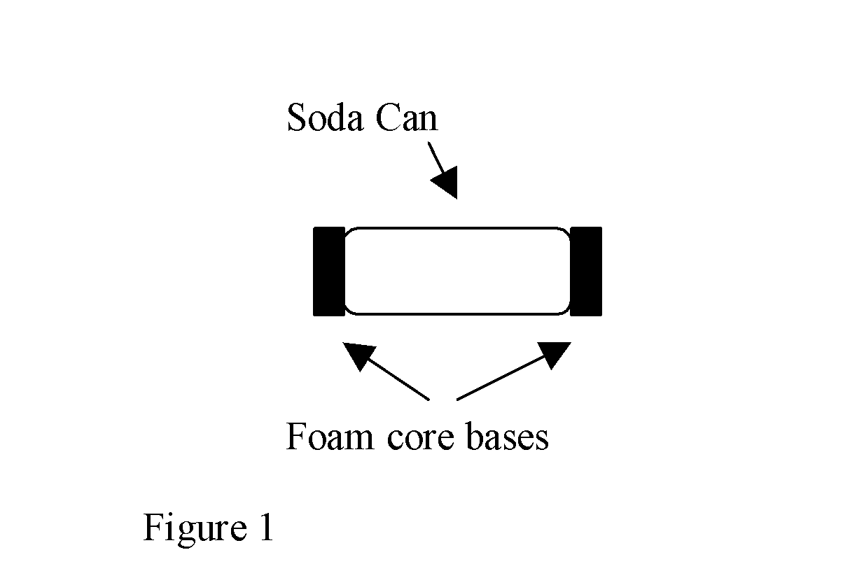

The chassis of the rover has to be:

- Sufficiently thick to carry the weight of the motor, switch, and battery holder.
- Sufficiently long to accommodate front and back wheels.
- Sufficiently sturdy to withstand the torque and pull of the motor, belt and rear wheels.

The “H” shape model is the usual standard.

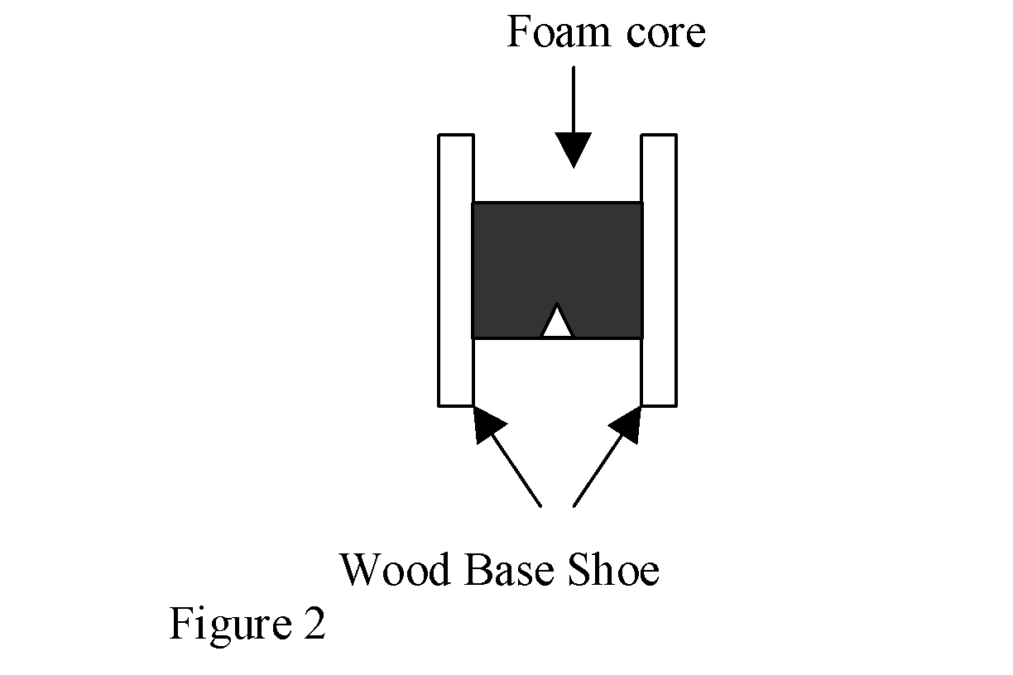

A series circuit is formed when an electrical source (battery) is connected to an object (motor, light…) which is connected to a switch which is connected back to the battery.
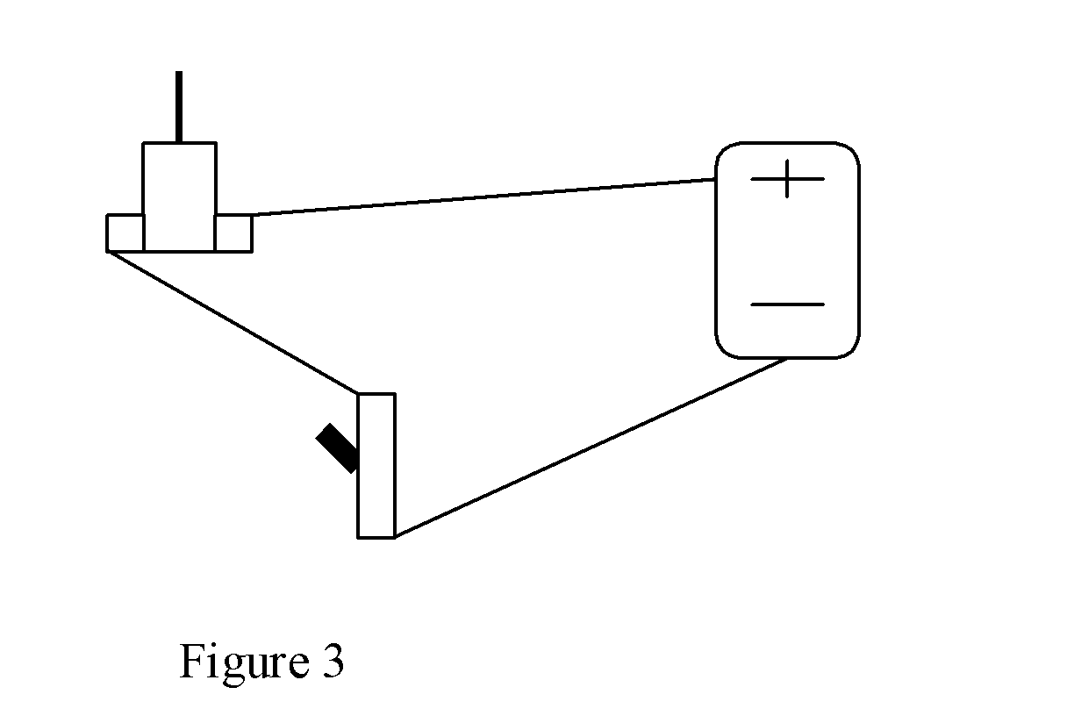
When the switch is off, the circuit is open and electricity can’t flow. When the switch is on, the circuit is closed and electricity can flow.

The rover must be assembled so that the wheels are placed at either end of the chassis and the motor stem is parallel to the rear wheel. A rubber band goes around the motor stem and rear wheel as a belt. This is the gearing system. The mechanical advantage is the ratio of the diameter of the can to the diameter of the motor stem. The greater this number, the stronger the turning force.

The variables to this design are in chassis length and width, suspension, and placement of the motor.

Procedure
- –Measure and cut four circles of foam core the same size as the end of a soda can.
- –Glue circles to both ends of each soda can (figure 1).
- –Cut 2 dowels about 3 inches longer than the soda cans.
- –Drill a hole in both ends of both soda cans (through the foam core).
- –Insert a dowel through both holes of one soda can (this is the wheel- axle)
- –Repeat step for the other can.
- –Cut a rectangle from the foam core (the width must be longer than a soda can).
- –Cut a “V” in one end.
- –Cut 2 pieces of wood base shoe. The wood must be long enough for both cans to spin freely when connected to the chasis.
- –Drill a hole in each end of one piece of wood.
- –Measure and mark the holes from the first piece of wood to the second to make sure the holes line up.
- – Drill a hole in each end of the other piece of wood where marked.
- –Glue the foam core to the pieces of wood using the “H” shaped model (figure 2).
- –Cut and strip 4 pieces of wire
- –Strip the wires of a battery holder.
- –Twist ends of two wires and solder to one lead of motor.
- –Twist ends of remaining two wires and solder to second lead of motor.
- –Solder the one wire of twisted pair from one motor lead to top lead of switch on one side.
- –Solder the other wire of twisted pair from one motor lead to top lead of switch on other side.
- –Solder the one wire of twisted pair from 2nd motor lead to top lead of switch on one side.
- –Solder the other wire of twisted pair from 2nd motor lead to top lead of switch on other side.
- –Solder red wire of battery holders wires to middle lead of switch.
- –Solder black wire of battery holders wires to middle lead of switch on other side (figure 3b).
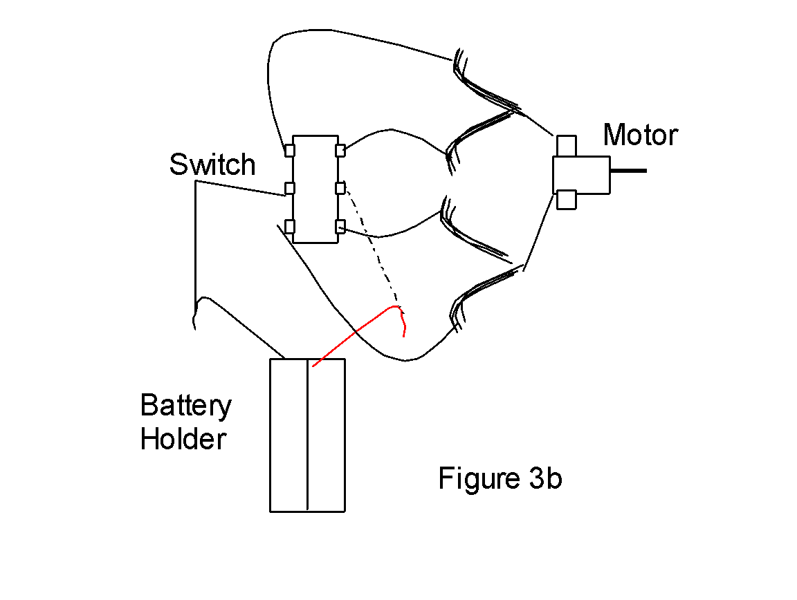
- –Test circuit with batteries.
- –Place three rubber bands around each can.
- –Attach wheel-axle suspension to chassis by inserting dowel ends into holes of wood on both ends (figure 4 below).
- –Secure wheel-axle by wrapping rubber bands on both ends of axle (on outside of wood base shoe) front and back.
- –Place tape over openings on motor and glue motor to chassis with the stem parallel to wheel axis and over the “V” (figure 5) Stem facing right makes car move one way, stem facing left makes car move the other way. Student must test before gluing to determine which way to glue motor.
- –Glue battery holder and switch to foam core or wood.
- –Place rubber band from can around stem of motor (student may have to place holder on end of stem to keep rubber band from sliding off).

Wrap-up
- Students compete for speed, direction, distance on incline, obstacles run over to determine the effect of suspension, chassis design, motor placement, wheel placement and alignment have on motion, friction, and horsepower.
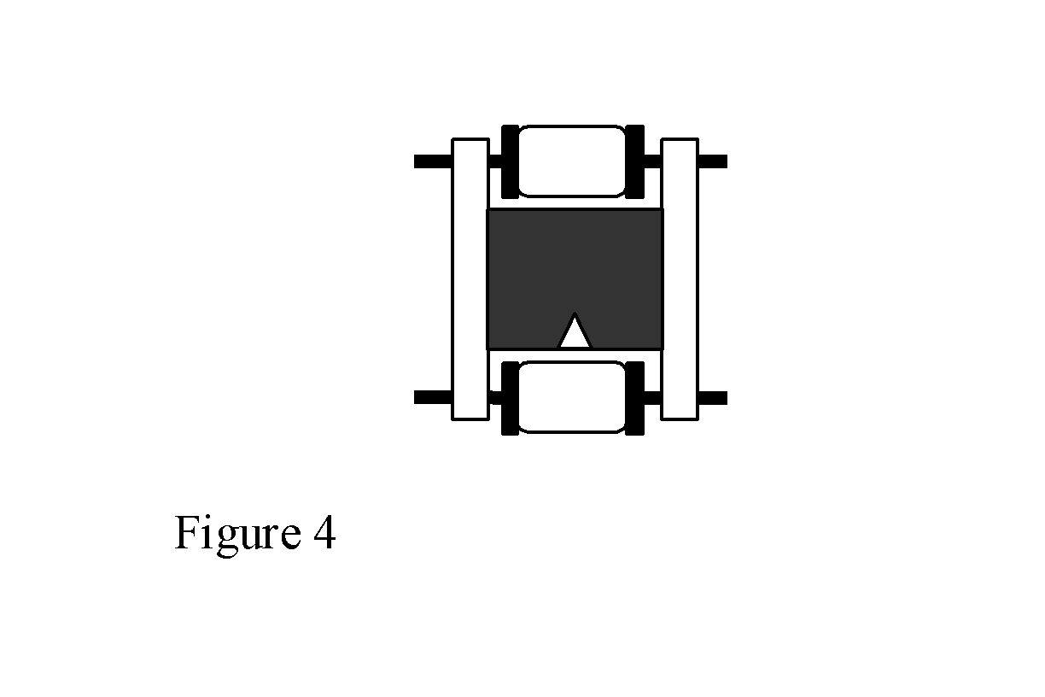
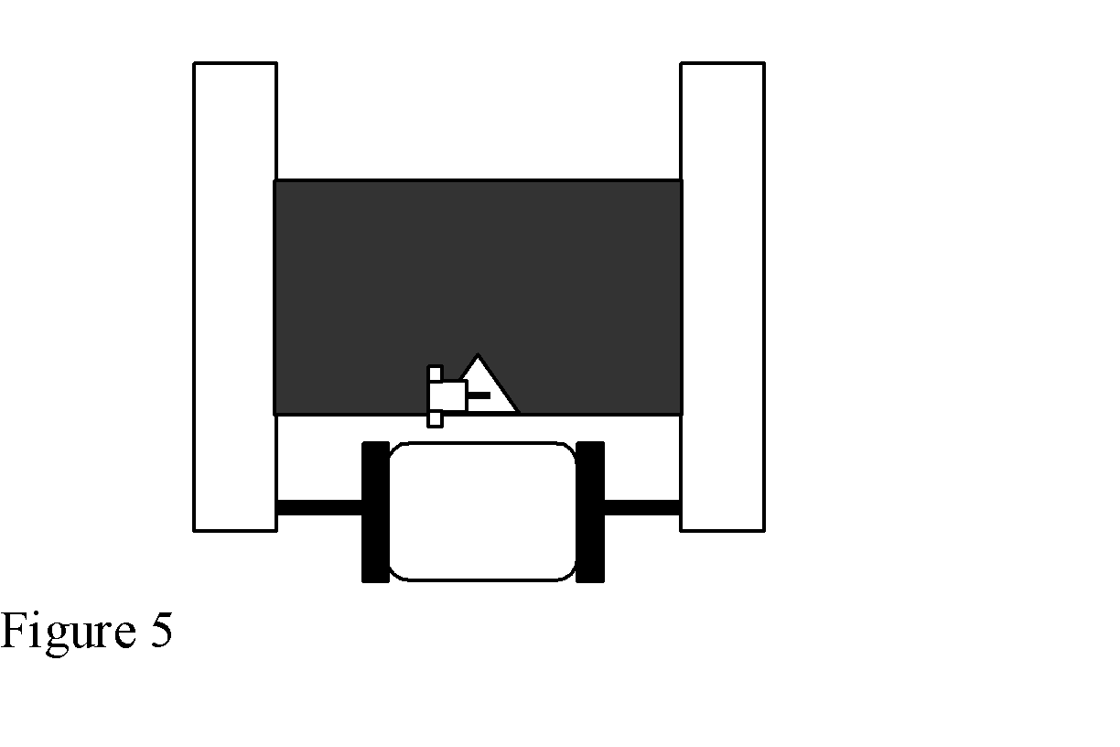

Lesson Background for Teachers

Safety Procedures
- Caution should be exercised with cutting utensils (scissors, X-acto blade).
- Students should be careful with hot surfaces (glue gun, soldering iron).
- Proper safety procedures and equipment should be used for drill, drill press and belt sander.

